Matej Popovski
STAT 436
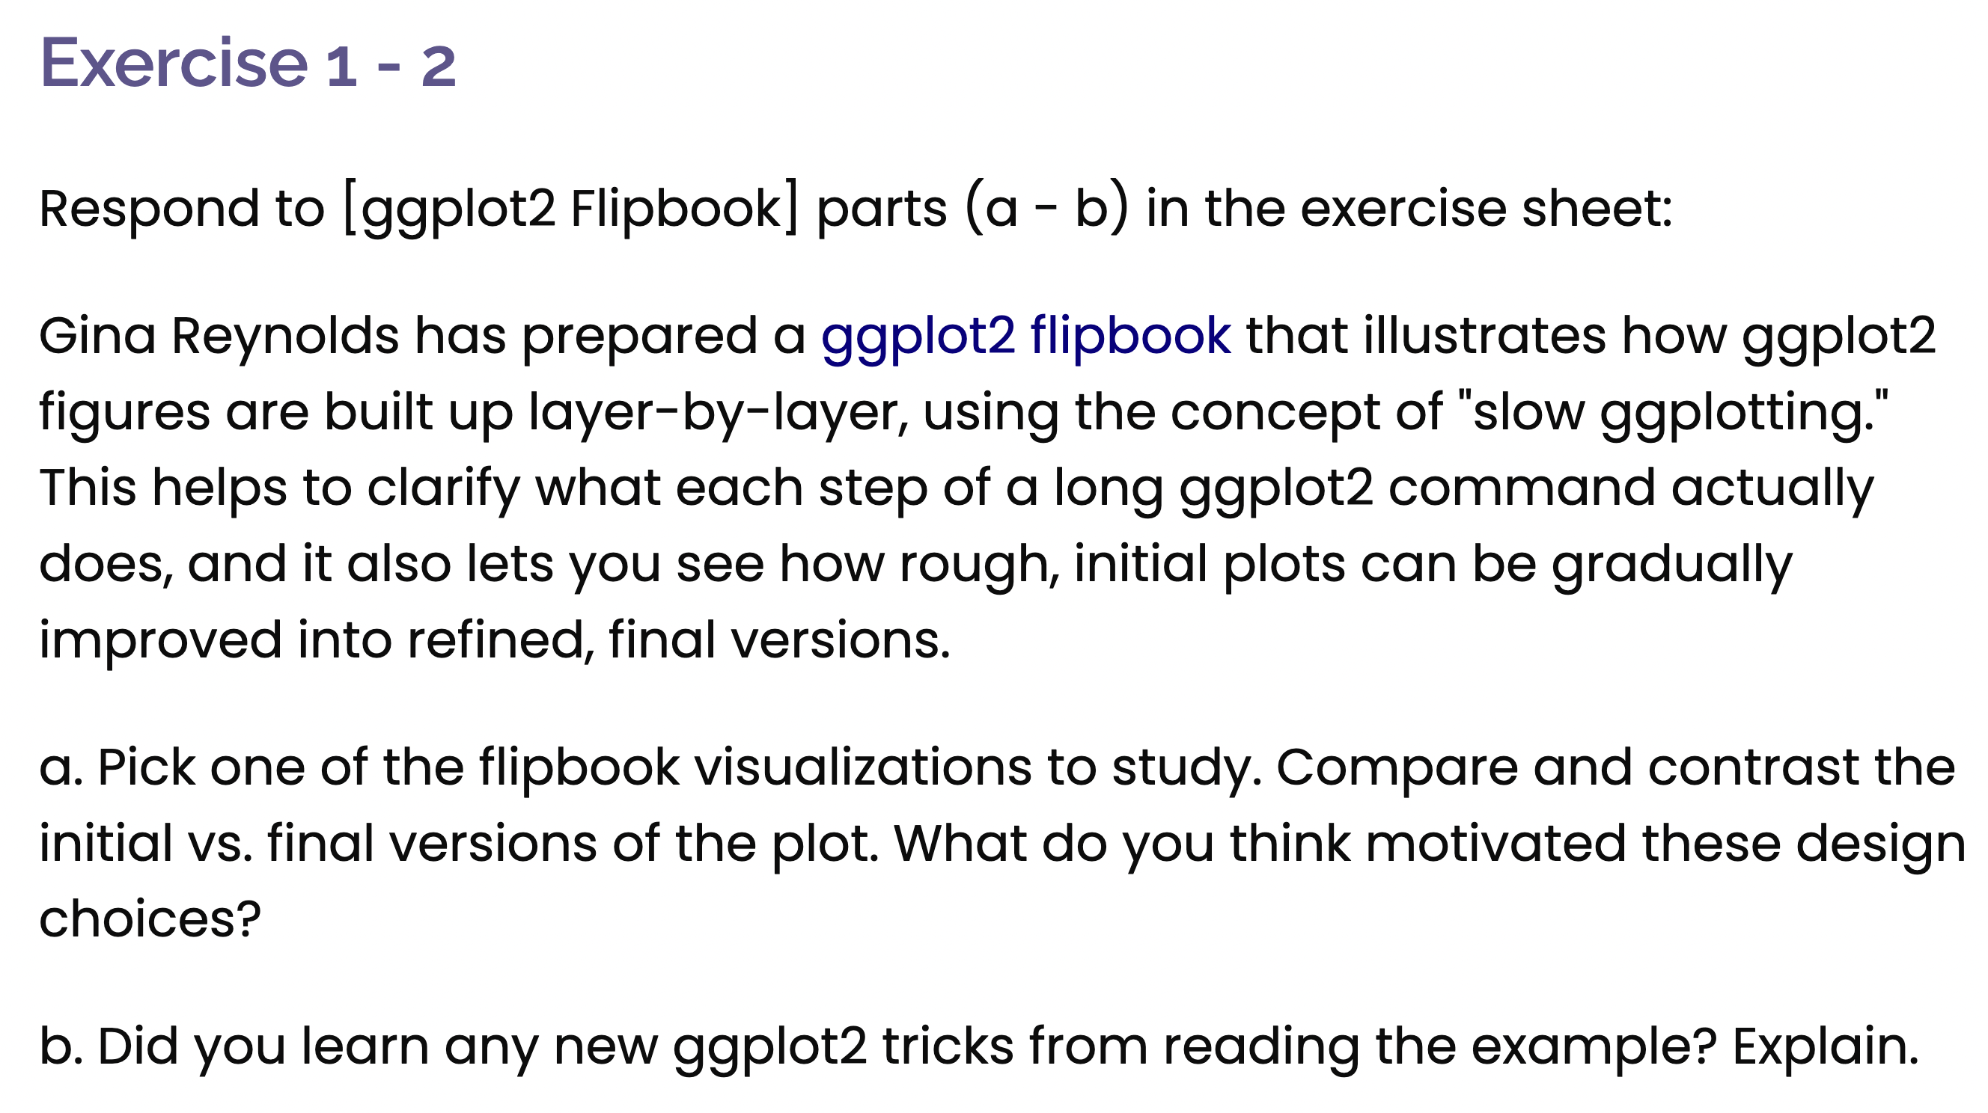
Exercise 1-2

I chose to improve the graphs displaying the number of murders in each state from the previous class to enhance their readability and effectiveness in conveying the data.
a) The improved plot effectively enhances clarity and readability by refining various aesthetic elements. Adjustments such as modifying axis labels, fine-tuning the color scheme, and optimizing data point visibility contribute to a more visually appealing and informative visualization. Additionally, improving the legend placement and adjusting text sizes make the plot easier to interpret.
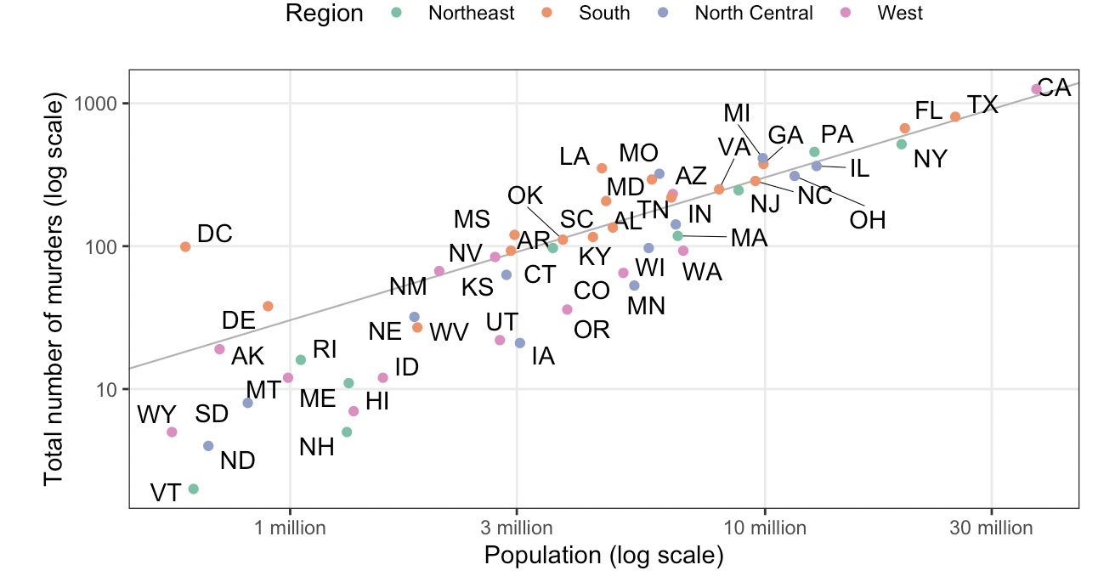
b) Through this exercise, I learned several useful ggplot2 techniques, including customizing themes, adjusting scales for better representation, and incorporating annotations for additional context. These skills will be valuable in creating more polished and professional data visualizations in the future.
